**Selecting S3 from the storage of the AWS service panel:**

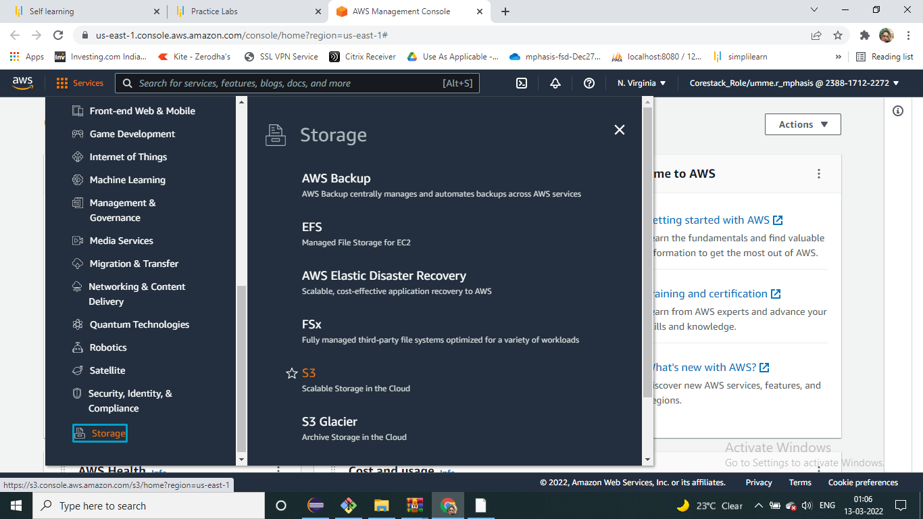

**Verifying the button to create a bucket:**

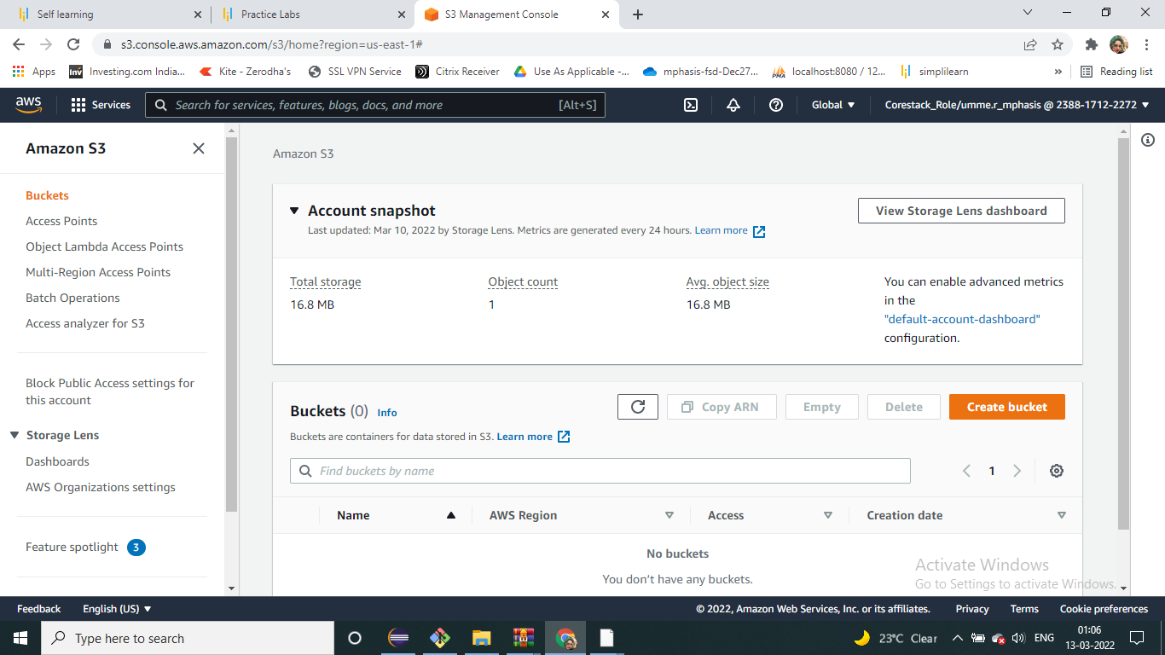

**Make sure that the bucket name is unique:**

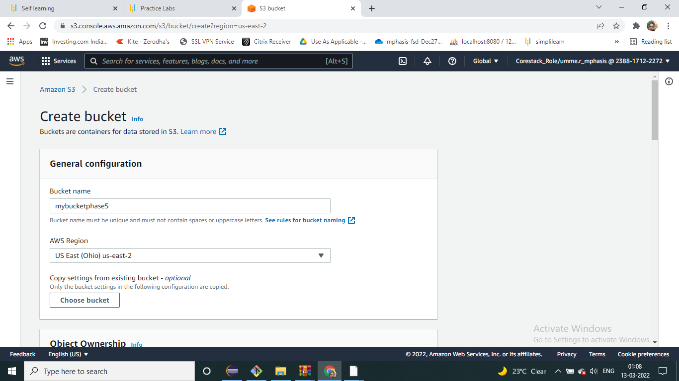

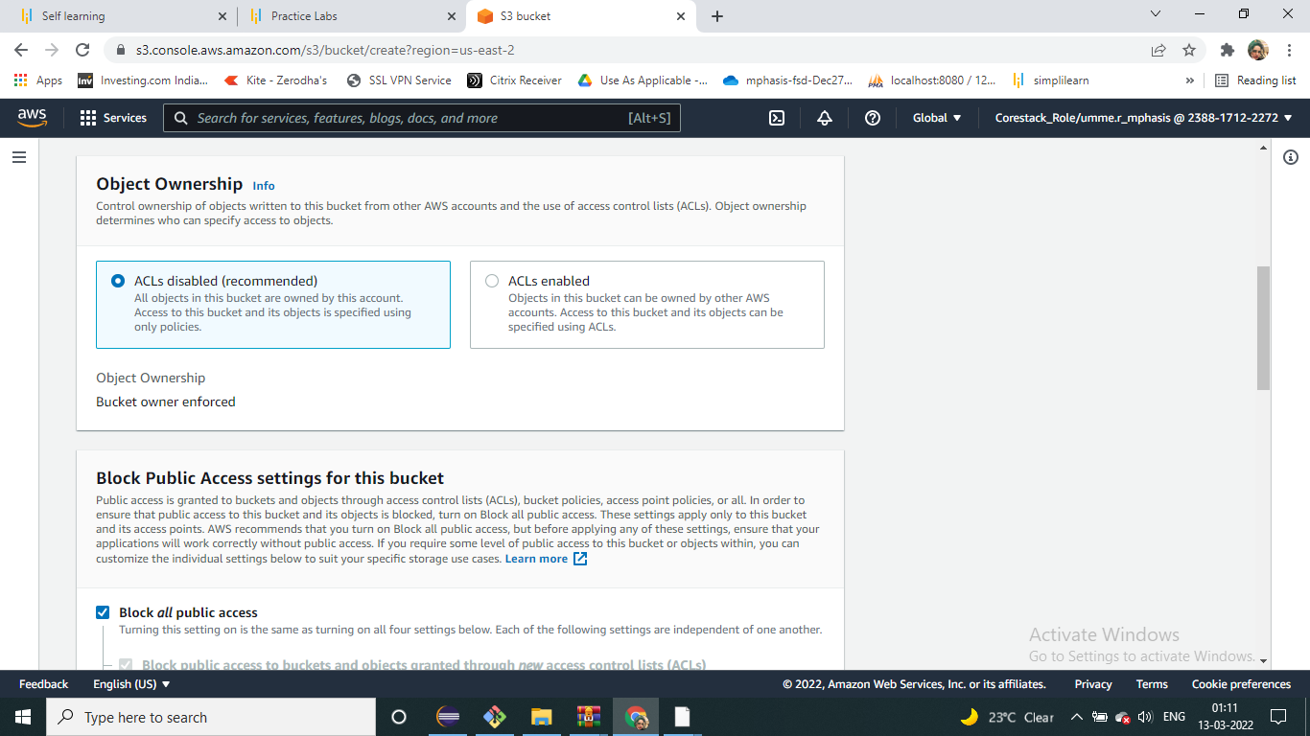

**Blocking all the public access :**

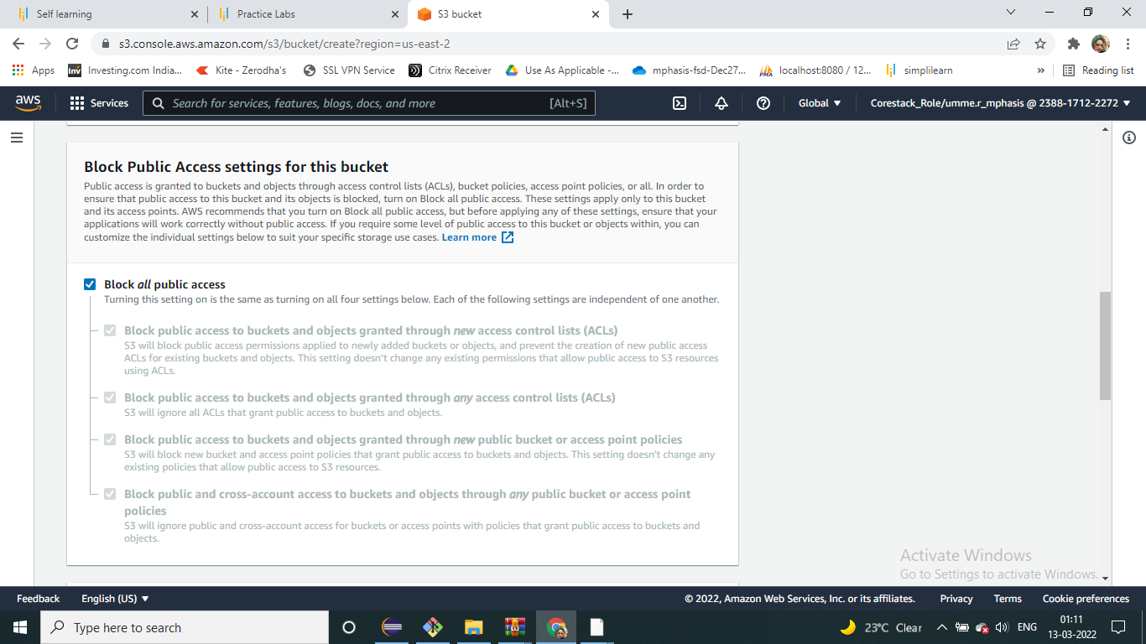

**Entering key and value for identification and tracking the bucket**

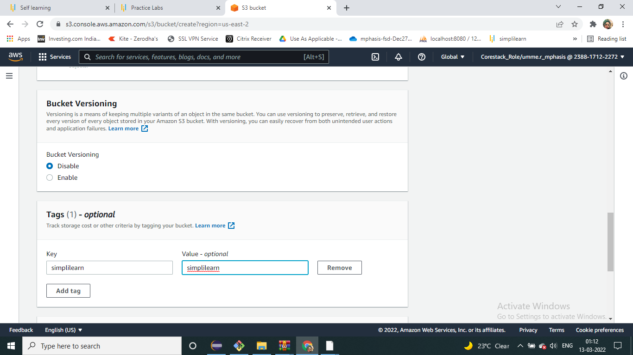

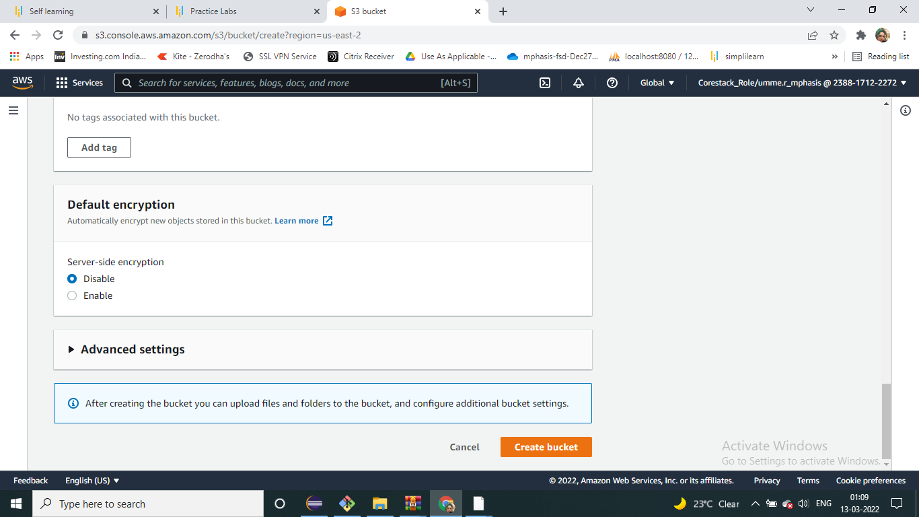

**Verifying the newly created bucket on the panel of S3**

